**1.INTRODUCTION**

**1.1 Overview**

This project is a restaurant recommendation system (RRS). A Recommendation System is an information filtering system that seeks to predict the rating a user would give for the item (in this case a restaurant). RRS is an on-line system to search restaurants. Visitors can browse all restaurants in L.A, and. Get information about restaurant name, type, rating, price. The functions include searching restaurants, viewing recommendations. Recommendation systems are important for increasing business revenue and giving users the ability to find desired restaurants of their taste. The system is challenging because many users don’t give ratings and we have new restaurants and users added to the system every day. In order to improve restaurant rating system, we need to predict the rating for the restaurant which are not rated. So it is important to build recommendation system for sparse rated restaurants. For this recommendation model, all that users have to input is a **restaurant name**that they have previously enjoyed visiting into the model and it will generate a list of the 10 most recommended restaurants based on the highest cosine similarity scores to that particular restaurant. For the **content-based recommendation model,** it works by recommending restaurants to users based on similar restaurant categories and dominant topic keywords, thus suggesting restaurants that align with a user’s preferences.

**1.2 Purpose**

The purpose of this system is to let people get ideas about which restaurant will be great for them. This system can give people some suggestions; also you can get others' opinions from this site. Further more, you can find the best restaurants by viewing the ratings page, which gathers many members' experience and response. This system is designed for people to search the information you send, and response all those restaurants matched the customers' request. Except viewing other's opinions, you can give suggestions by rating restaurants to other people. This system is like a communication bulletin for people who love to eat. In this site, the customer need to search restaurants by their names. They will get a page describing the related names of the restaurants and their type and ratings.

1. **LITERATURE SURVEY**

**2.1 Existing problem and Existing approaches or methods**

As we are users of recommendation applications, people care more about how we will like a restaurant. It is very common that we hang out with families, friends, and co-workers. when comes to lunch or dinner time. In the past, people obtained suggestions for restaurants from friends. Although this method is straightforward and user-friendly, it has some severe limitations. First, the recommendations from friends or other common people are limited to those places they have visited before. Thus, the user is not able to gain information about places less visited by their friends. Besides that, there is a chance of users not liking the place recommended by their friends.

**2.2 Disadvantages of existing system**

* Collecting large amount of data set.
* Large number of training data and annotations are needed which may not be practical in some problems.

**2.3 Proposed solution**

Here we are creating a content-based recommendation system. The aim is to create a content-based recommender system in which when we will write a restaurant name, the Recommender system will look at the reviews of other restaurants, and the System will recommend us other restaurants with similar reviews and sort them from the highest-rated. The main people who are going to benefit from this recommendation system are the tourists, who are new to a city. Most of the tourists always love to visit famous restaurants in a particular city during their visit. Otherwise, it can be heavily used by people belonging to the same city, to see if any new restaurant is recommended based on their activity.

**2.4 Proposed algorithams**

**I. k-nearest neighbor algorithm:**

* It is a supervised machine learning algorithm. The algorithm can be used to solve both

classification and regression problem statements. The number of nearest neighbor's to

a new unknown variable that has to be predicted or classified is denoted by the

symbol 'K'.

* KNN algorithm at the training phase just stores the dataset and when it gets new data,

then it classifies that data into a category that is much similar to the new data.

* K-Nearest Neighbors (KNN) is one of the simplest algorithms used in Machine

Learning for regression and classification problem. KNN algorithms use data and

classify new data points based on similarity measures (e.g. distance function). The

data is assigned to the class which has the nearest neighbors.

* It's also worth noting that the KNN algorithm is also part of a family of ―lazy

learning‖ models, meaning that it only stores a training dataset versus undergoing a training stage. This also means that all the computation occurs when a classification or prediction is being made. Since it heavily relies on memory to store all its training data, it is also referred to as an instance-based or memory-based learning method.

* The K-NN working can be explained on the basis of the below algorithm:

Step-1: Select the number K of the neighbors

Step-2: Calculate the Euclidean distance of K number of neighbors

Step-3: Take the K nearest neighbors as per the calculated Euclidean distance.

Step-4: Among these k neighbors, count the number of the data points in each category.

Step-5: Assign the new data points to that category for which the number of the neighbor

is maximum.

Step-6: Our model is ready.

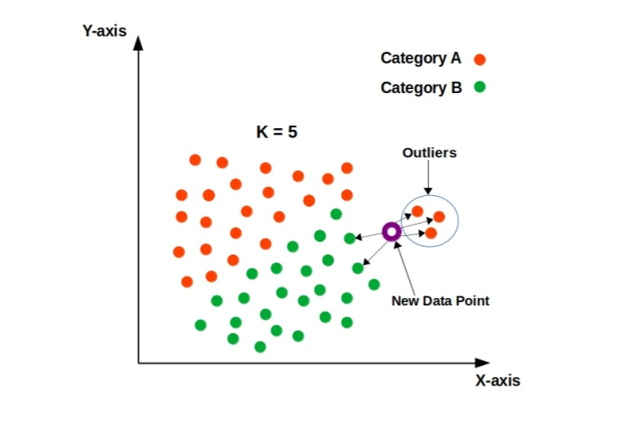

**Figure 1**:KNN Algorithm

**II.Linear Regression**

The most common is the linear regression algorithm. The linear regression algorithm is used to find the best linear approximation to a data set. In a recommender system, this algorithm is used to predict how a user will rate an item based on their past ratings

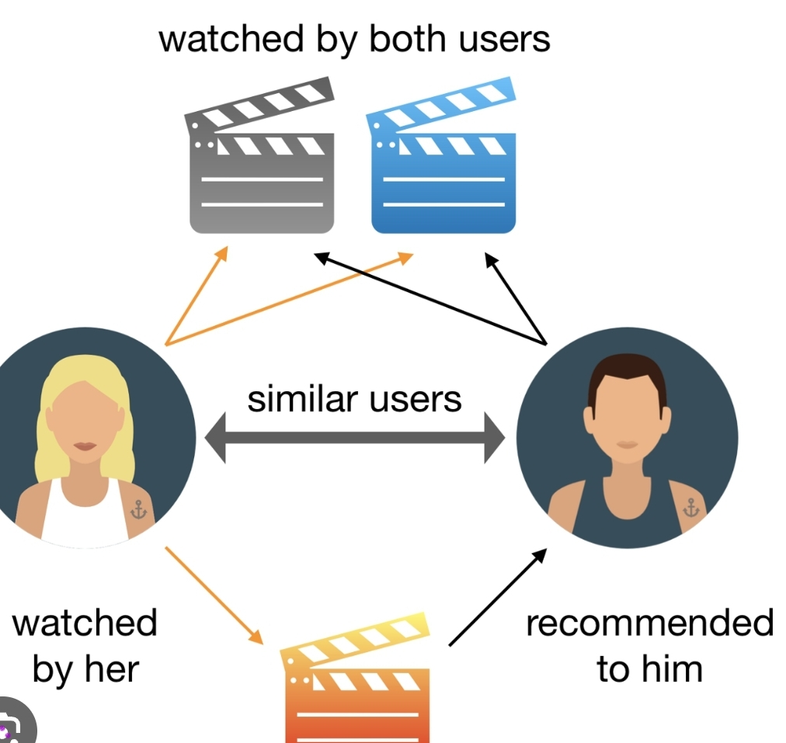

Linear Regression is a supervised machine learning algorithm where the

predicted output

**Figure 2:** Linear Regression

**3.THEORITICAL ANALYSIS**

**3.1 Block Diagram**

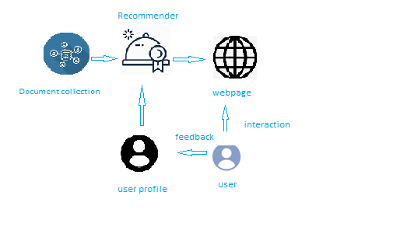

**Figure3**. Block diagram

**3.2 Hardware and Software**

Software Requirements:

To complete this project, you must require the following software’s, concepts, and packages

Anaconda navigator

Python packages:

* pandas
* matplotlib
* seaborn
* plotly
* numpy
* scikit-image
* scikit-learn
* Flask

Hardware Requirements

* Processor : Intel Core i3
* Hard Disk Space : Min 100 GB
* Ram : 4 GB
* Display : 14.1 “Color Monitor(LCD, CRT or LED)
* Clock Speed : 1.67 GHz

**4.EXPERIMENTAL INVESTIGATION**

For developing the project the team has completed several tasks:

1.Data Collection.

ML depends heavily on data, without data, a machine can't learn. It is the most crucial aspect that makes algorithm training possible. In Machine Learning projects, we need a training data set. It is the actual data set used to train the model for performing various actions.

You can collect datasets from different open sources like kaggle.com, data.gov; UCI

machine learning repository etc. The dataset used for this project was obtained from Kaggle.

2. Data Pre- processing.

Data Pre-processing includes the following main tasks

* + Import the Libraries.
  + Importing the dataset.
  + Analysis the data
  + Taking care of missing Data
  + Exploratory Data Analysis
  + Data Visualization.
  + Splitting Data into Train and Test

3.Model Building

The model building process involves setting up ways of collecting data, understanding

and paying attention to what is important in the data to answer the questions you are asking, finding a statistical, mathematical or a simulation model to gain understanding and make predictions. Model Building Includes:

* + - Import the model building libraries
    - Initialising the model
    - Training the model
    - Model evalution
    - Save the model

4. Application Building

* 1. Create an HTML file
  2. Build a Python Code
  3. Run the app in local browser
  4. Show casting the prediction on UI

**5.FLOW CHAT**

Importing the necessary libraries

Loading the dataset

Training the model

Testing the model

**Figure.4** Flowchart

**6.DESIGN**

Collect the dataset or creat the dataset

Import the libraries

Import the dataset

DATA COLLECTION

Exploratory Data Analysis

DATA PREPROCESSING

daData Visulization

MMerging dataset

MODEL BUILDING

Creating the recommender system

Predicting the results

APPLICATION BUILDING

Create an HTML file

Build Build a python code

**Pre requisties**

To complete the project successfully, you need to install following software & packages**:**

**Install Anaconda IDE/Anaconda Navigator**

In order develop a solution to this problem statement, we need an environment to write and test the code**.**

We use Anaconda IDE (Integrated Developing Environment).

Refer to the below link to download & install Anaconda Navigator.

**To Build Machine Learning Models You Must Require The Following Packages**

Numpy:

It is an open-source numerical Python library. It contains a multidimensional array and matrix data structures and can be used to perform mathematical operations

Matplotlib and Seaborn

Matplotlib is mainly deployed for basic plotting. Visualization using Matplotlib generally consists of bars, pies, lines, scatter plots and so on. Seaborn: Seaborn, on the other hand, provides a variety of visualization patterns. It uses fewer syntax and has easily interesting default themes.

Flask:

Web framework used for building Web applications

If you are using anaconda navigator, follow below steps to download required packages:

Open anaconda prompt.

Type “pip install pandas” and click enter.

Type “pip install matplotlib” and click enter.

Type “pip install seaborn” and click enter.

Type “pip install plotly” and click enter.

Type “pip install numpy” and click enter.

Type “pip install scikit-image” and click enter.

Type “pip install scikit-learn” and click enter.

Type “pip install Flask” and click enter.

**7.PROJECT STRUCTURE**

* User interacts with the UI (User Interface) to enter the input features.
* Entered features/input is analysed by the model which is integrated
* Once model analyses the entered inputs, the prediction is showcased on the UI.

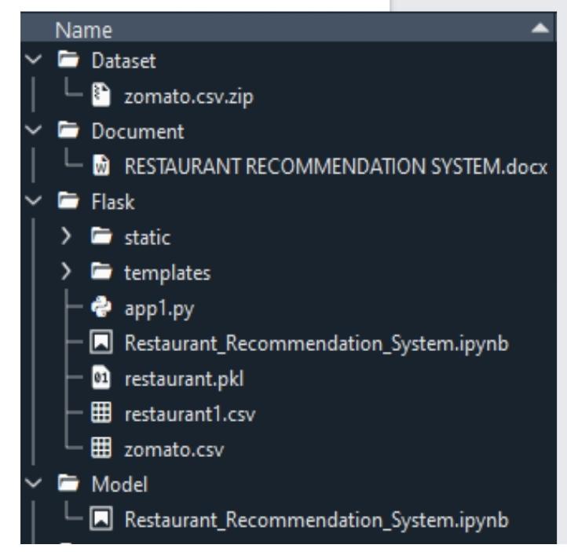

* **Figure 5**: Project Structure

.

**8.CONCLUSION**

The main objective of the study is to develop the restaurant recommendation system using machine learning with the web interface that can act as a application for the customers. This application is used for the users to predict the suitable restaurant and find out which dish is famous in region wise and in person. This application ensures the availability of ratings to the customers. The popularity based and collaborative based filtering makes the recommendation more efficient so that each user can use this application for their easy prediction of restaurant. Most the case user need the restaurant with their nearby location. We also solving that issue by adding the restaurant location in our dataset. So that our machine learning algorithm easily predicts the restaurant for the customer with their present location. This restaurant recommendation system web application will provide user a better experience in searching of restaurant with short amount of time and nearby location. This will decrease the user’s effort and makes the time more precious.

**9.FUTURE SCOPE**

To build more friendly graphical interfaces, the next goal for a further project is to improve the performance of system and improve the member's benefit such as providing more functions for member, like online reservation function, online order menu, and website, etc.

**0**

**1.INTRODUCTION**

A recommendation system or recommender system is a type of information filtering system that uses various features given about user and product and tries to predict the most similar pairs to identify the best products according to user taste that a user is most likely to consume and return positive feedback.

Machine learning (ML) is a type of artificial intelligence (AI) that allows software applications to become more accurate at predicting outcomes without being explicitly programmed to do so. Machine learning algorithms use historical data as input to predict new output values. Here we are building a model by applying various machine learning algorithms find the best accurate model. So we can easily find which restaurant is best in the new places to vigistors. On our Dataset , we have applied Random Forest Regression and KNN algorithms.

The abbreviation KNN stands for ―K-Nearest Neighbour‖. It is a supervised machine learning algorithm. The algorithm can be used to solve both classification and regression problem statements. The number of nearest neighbours to a new unknown variable that has to be predicted or classified is denoted by the symbol 'K'.

UG Project Phase-2 involves all the coding and implementation of the design which we have retrieved from UG Project Phase-1. All the implementation is done and conclusions are retrieved in this phase. We will also work on the applications, advantages, and disadvantages of the project in this phase. Future scope of the project will be also discussed in the UG Project Phase-2

**2.CODE SNIPPETS**

**2.1 .MODEL CODE:**

**Data Preprocessing**

Data Pre-processing includes the following main tasks

1.Import the Libraries.

2.Importing the dataset.

3.Checking for Null Values.

4.Data Visualization.

5.Label Encoding.

6.OneHot Encoding.

7.Splitting Data Into Train and Test.

Import the below essential libraries for data pre-processing and creating recommendation system. Pandas and NumPy are used for data pre-processing and cleaning. Seaborn, Plotly and Matplotlib helped in creating visual graphics and bar plots for the dataset. Also, since there would be cleaning of text data (reviews) as well, therefore for that we will use nltk and sklearn library.

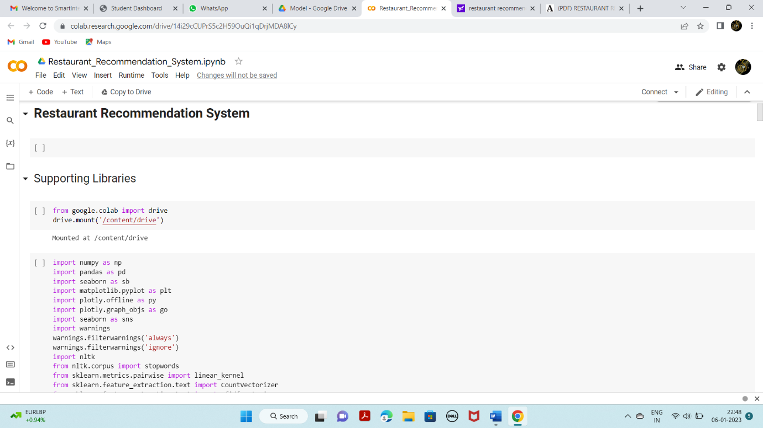

Our dataset format might be in .csv, excel files, .txt, json, etc. We can read the dataset with the help of pandas.

In pandas we have a function called read_csv () to read the dataset. As a parameter we have to give the directory of csv file.

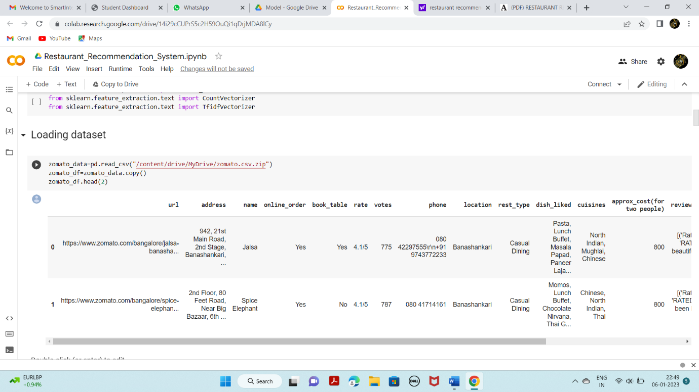

Understanding Overview of features

* How the information is stored in a DataFrame or Python object affects what we can      do with it and the outputs of calculations as well. There are two main types of data those are numeric and text data types.
* Numeric data types include integers and floats.
* Text data type is known as Strings in Python, or Objects in Pandas. Strings can contain numbers and / or characters.
* For example, a string might be a word, a sentence, or several sentences.
* Will see how our dataset is, by using info () method.

.

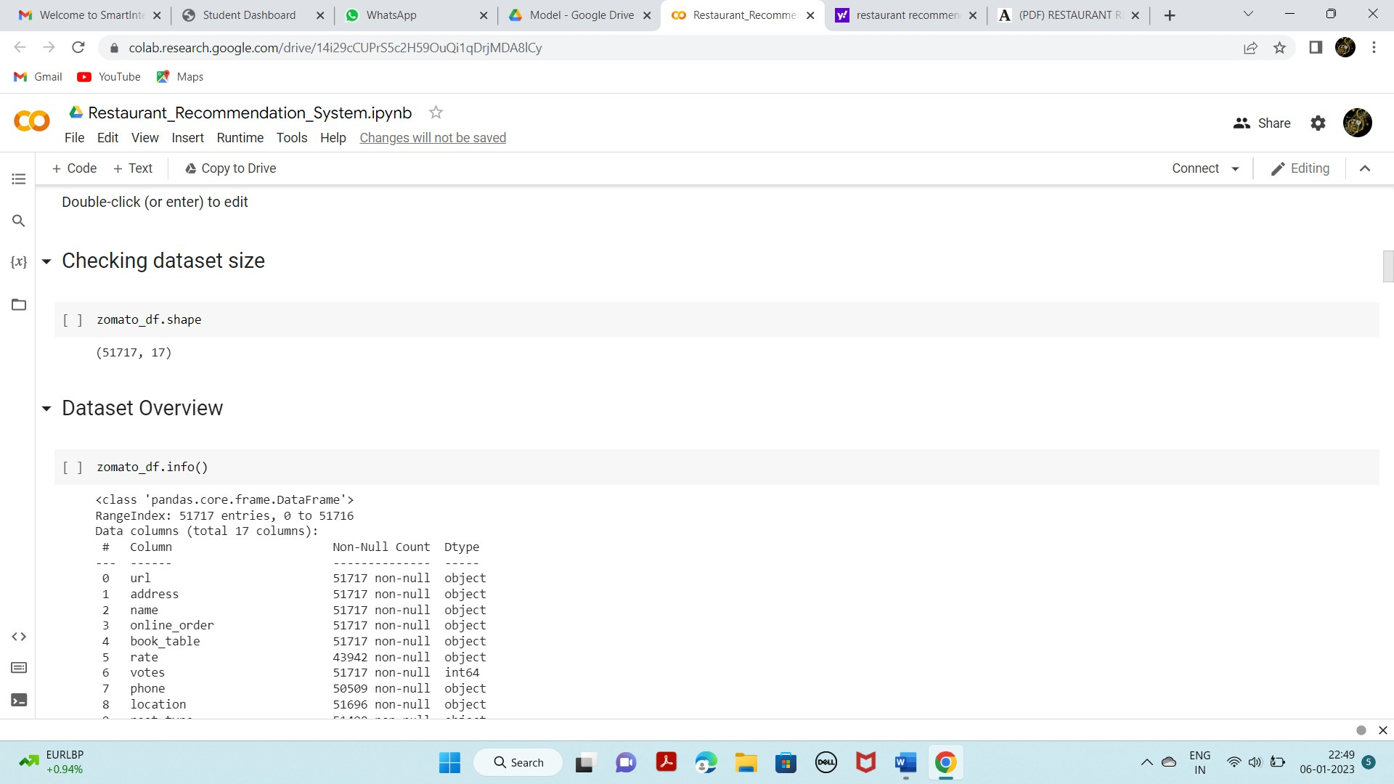

As you can see in our dataset, except ‘votes’, all other features are categorical data, but it is not necessary that all the continuous data which we are seeing has to be continuous in nature. There may be a case that some categorical data is in the form of numbers but when we perform info () operation we will get numerical output. So, we need to take care of those type of data also

Checking for null values in the dataset

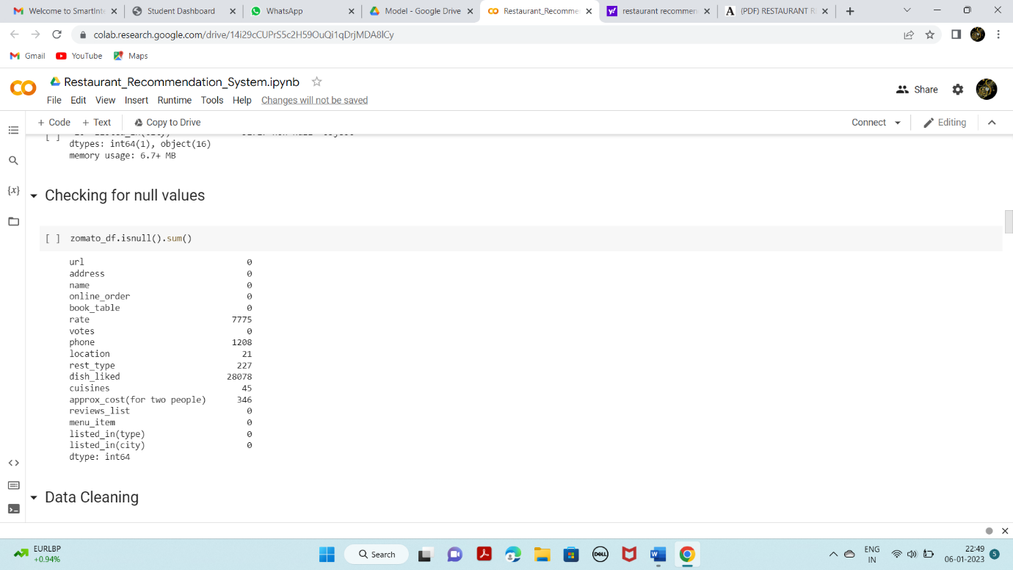

Data cleaning as our dataset contains null values and some special characters

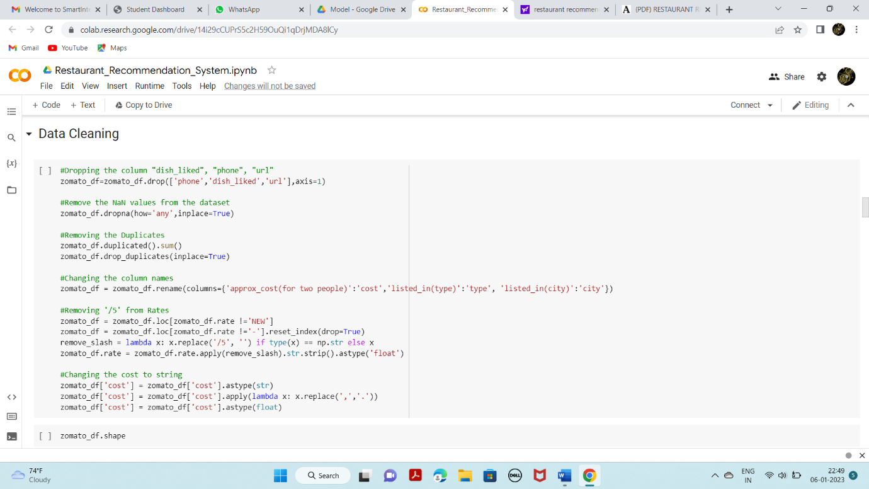

Checking for null values after cleaning & data Processing

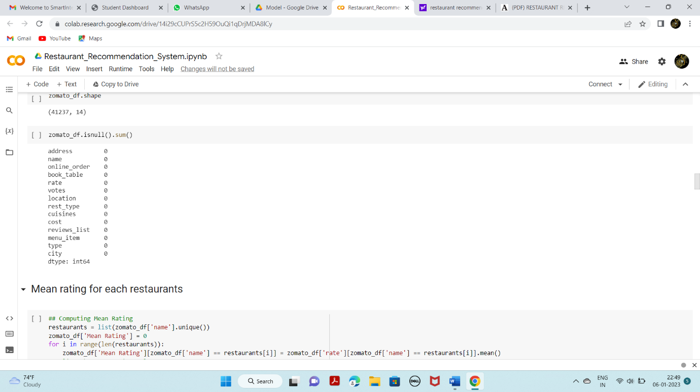

Checking mean rating with restaurant name and rating for each restaurant using below line codes

We will be using the ‘Review’ and ‘Cuisines’ feature in order to create a recommender system. So we need to prepare and clean the text in those columns.

Operations performed: Lower Casing, Removal of Punctuations, Removal of Stop words, Removal of URLs, Spelling correction

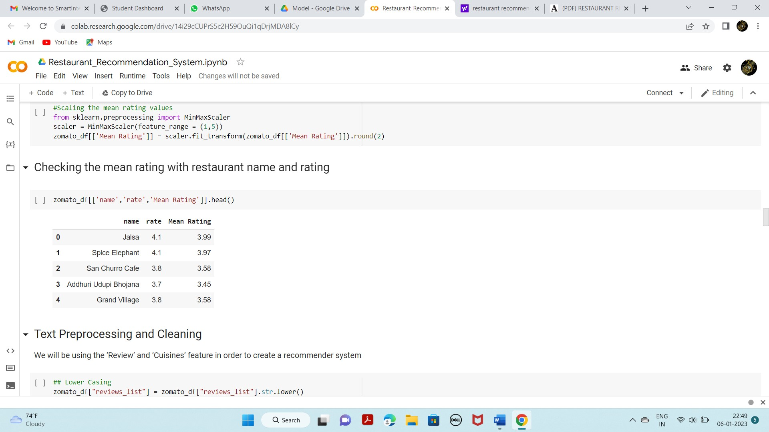

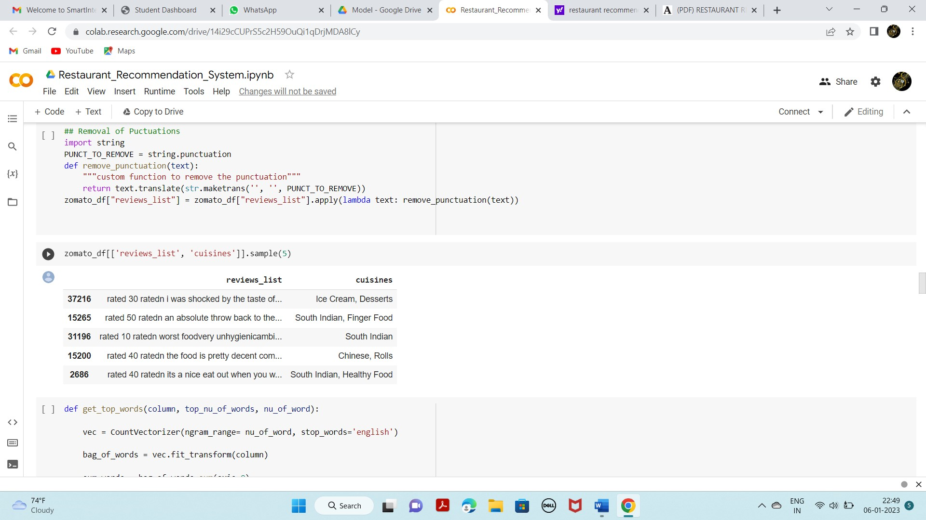

We will be using the ‘Review’ and ‘Cuisines’ feature in order to create a recommender system. So we need to prepare and clean the text in those columns.

Operations performed: Lower Casing, Removal of Punctuations, Removal of Stop words, Removal of URLs, Spelling correction

To visualize the dataset, we need libraries called Matplotlib, Seaborn. The Matplotlib library is a Python 2D plotting library which allows you to generate plots, scatter plots, histograms,

bar charts etc.

Let’s visualize our data using Matplotlib and seaborn library.

At first, we will be plotting a bar plot using matplotlib for showing the top 6 restaurants in Bangalore by value counts

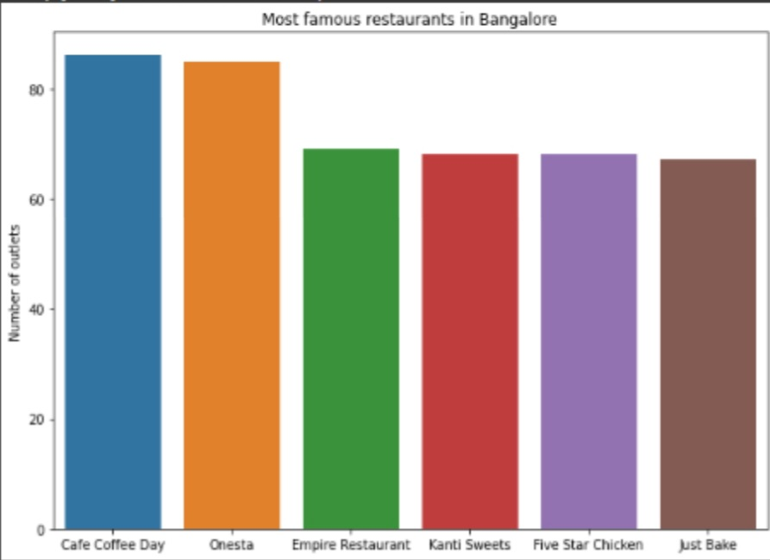

Checking the distribution of restaurant rating, for that we are using distplot from seaborn library

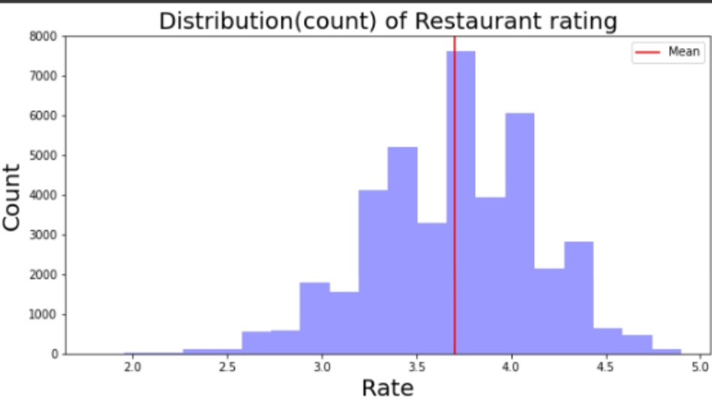

And we can infer that most of the restaurants in Bangalore have rating above 3.5.

Visualizing top 10 rated restaurants in Bangalore. For that we are again using barplot from Matplotlib library

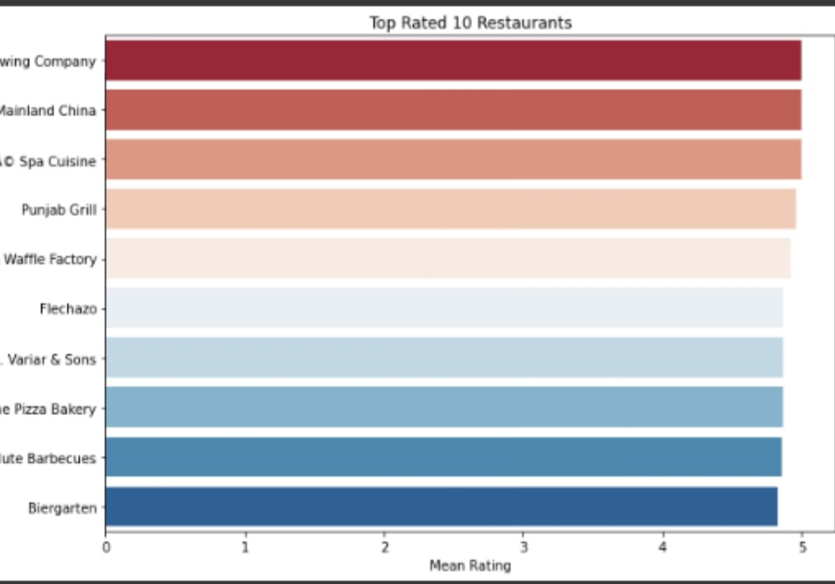

Visualizing two word frequencies for cuisines, using barplot from seaborn library.

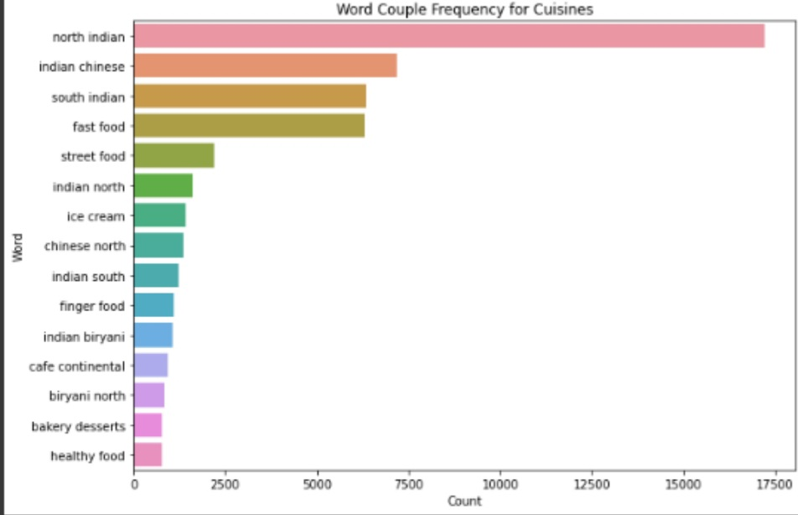

Here we can see the Top favourite cuisine among people of Bangalore is ‘North Indian’, ‘Indian Chinese’ and ‘Fast food’.

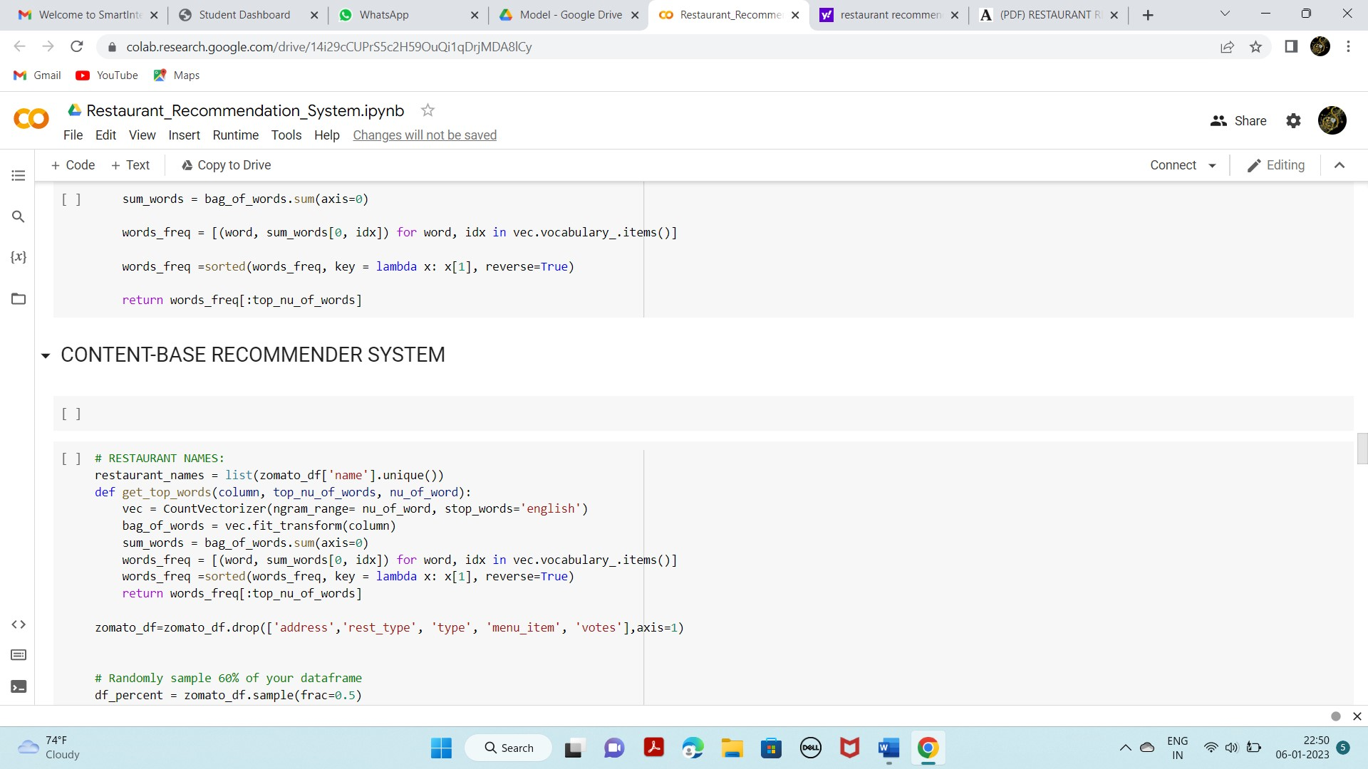

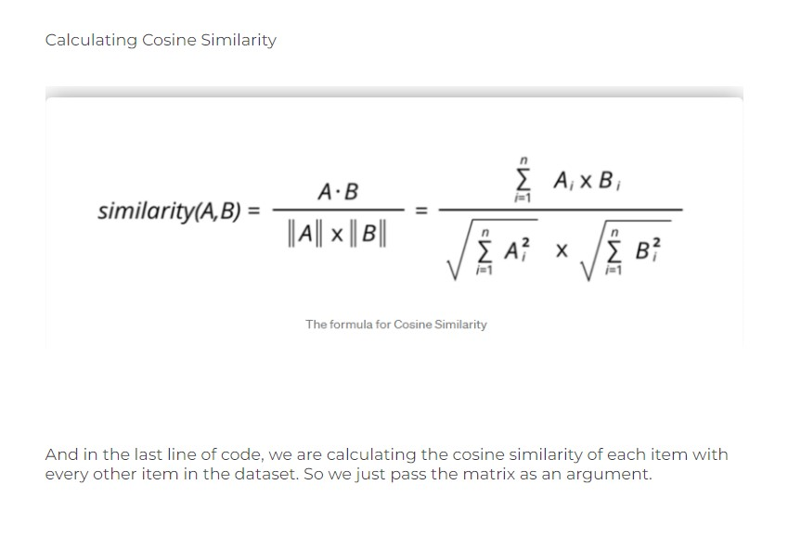

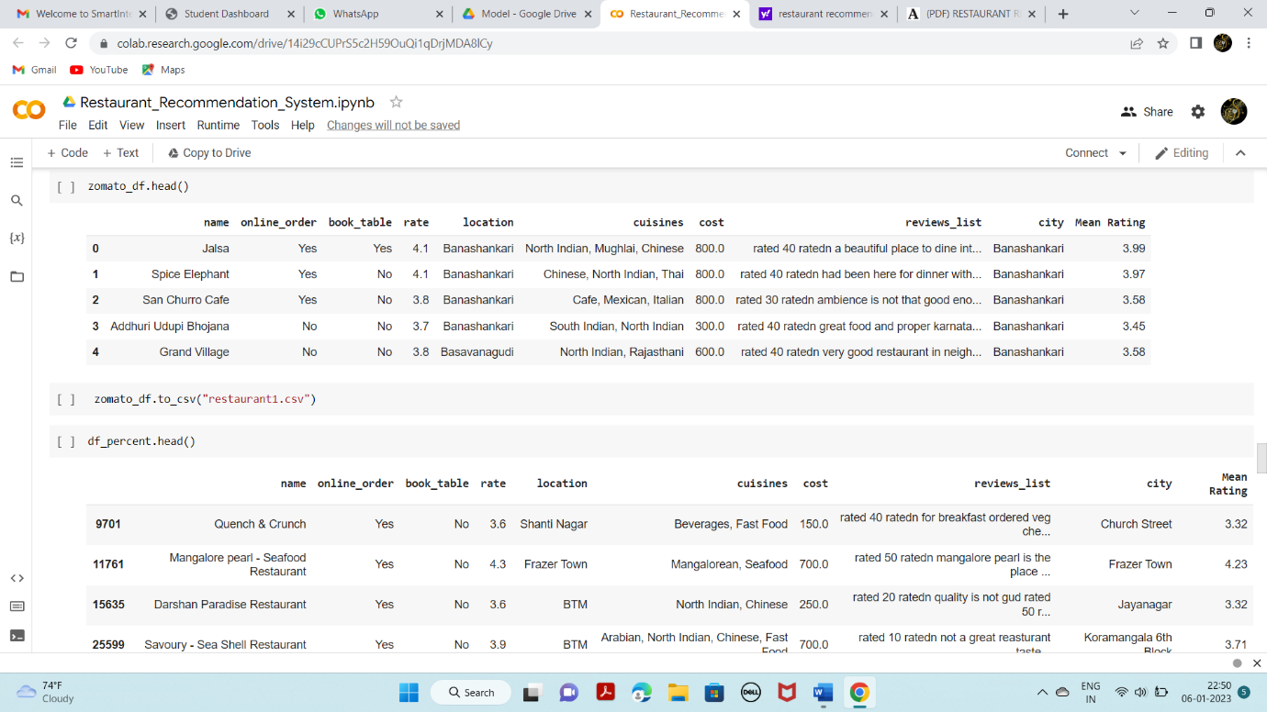

**TF-IDF Matrix (Term Frequency — Inverse Document Frequency Matrix)**

TF-IDF is a statistical method of assessing the meaning of a word in a given document. Now we use TF-IDF vectorization on the dataset.

Cosine similarity is a metric used to determine how similar the documents are irrespective of their size. Calculating the cosine similarity of each item with every other item in the dataset.

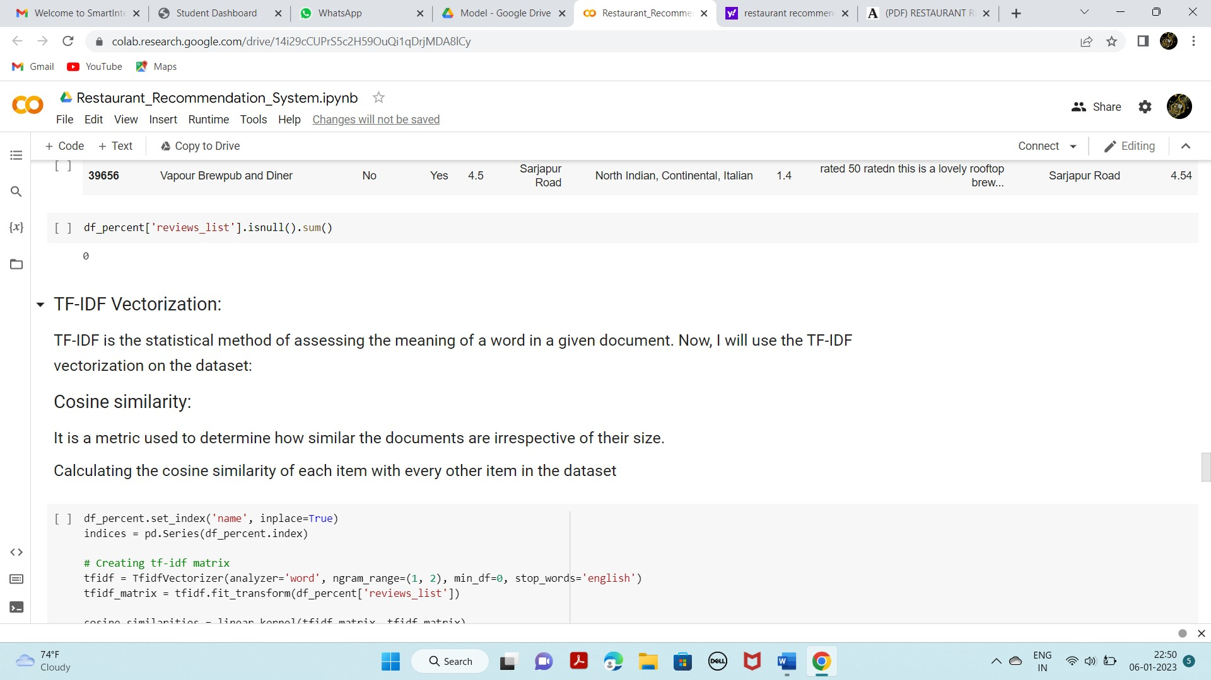

Here, the tf-idf matrix is the matrix containing each word and its TF-IDF score with regard to each document, or item in this case. Also, stop words are simply words that add no significant value to our system, like ‘an’, ‘is’, ‘the’, and hence are ignored by the system.

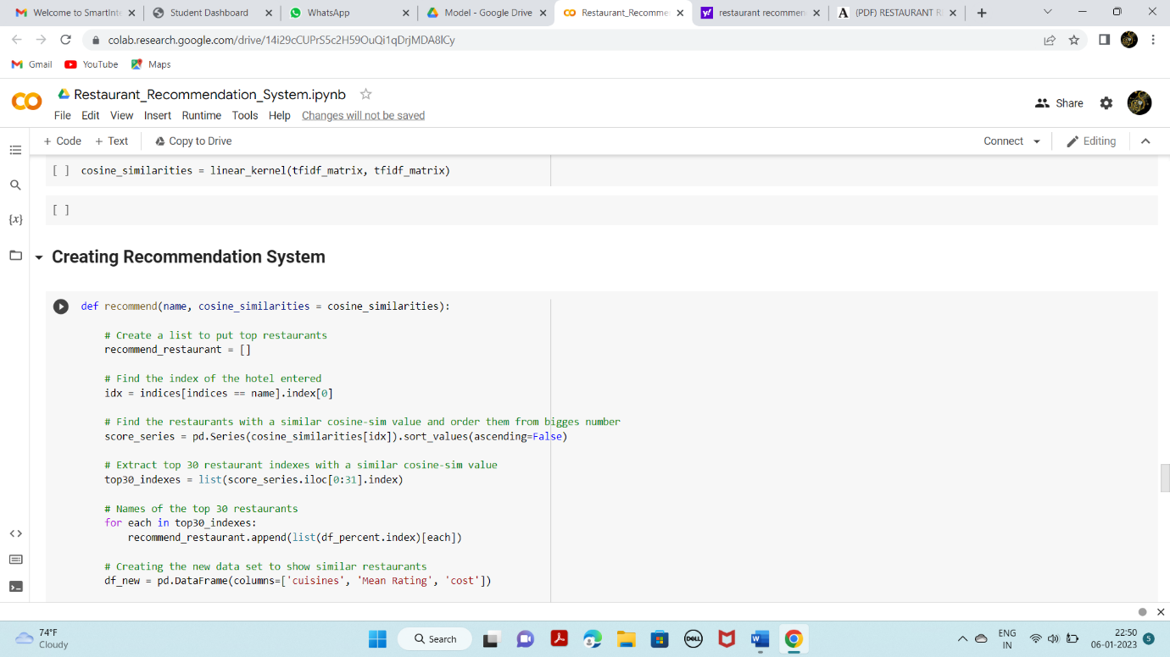

Querying recommendation for 4 Restaurants:

For Restaurant ‘Red Chilliez’

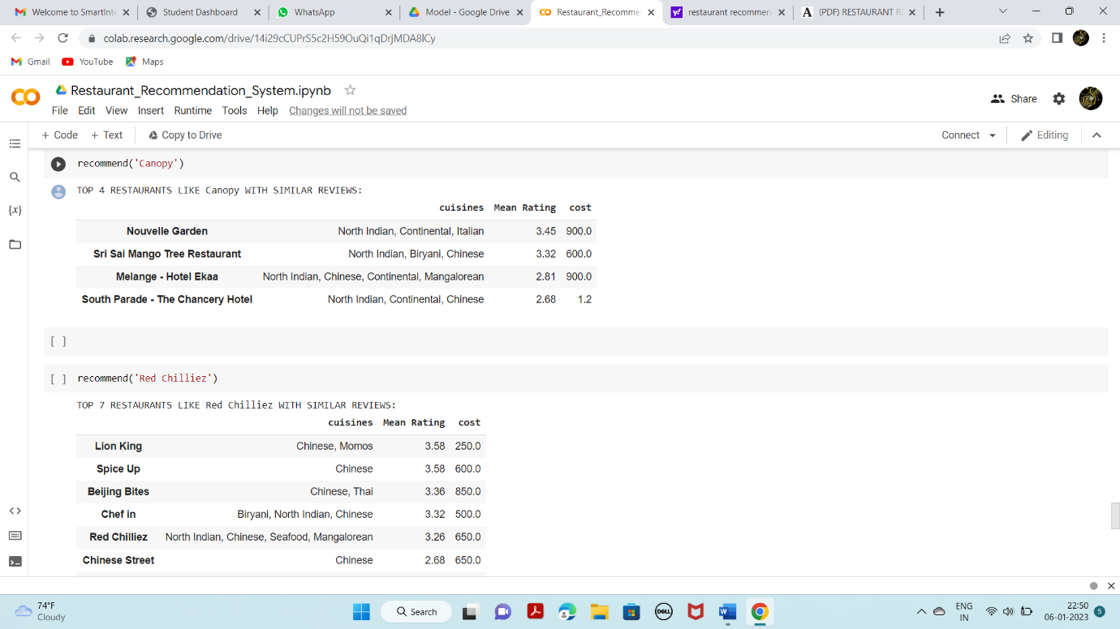

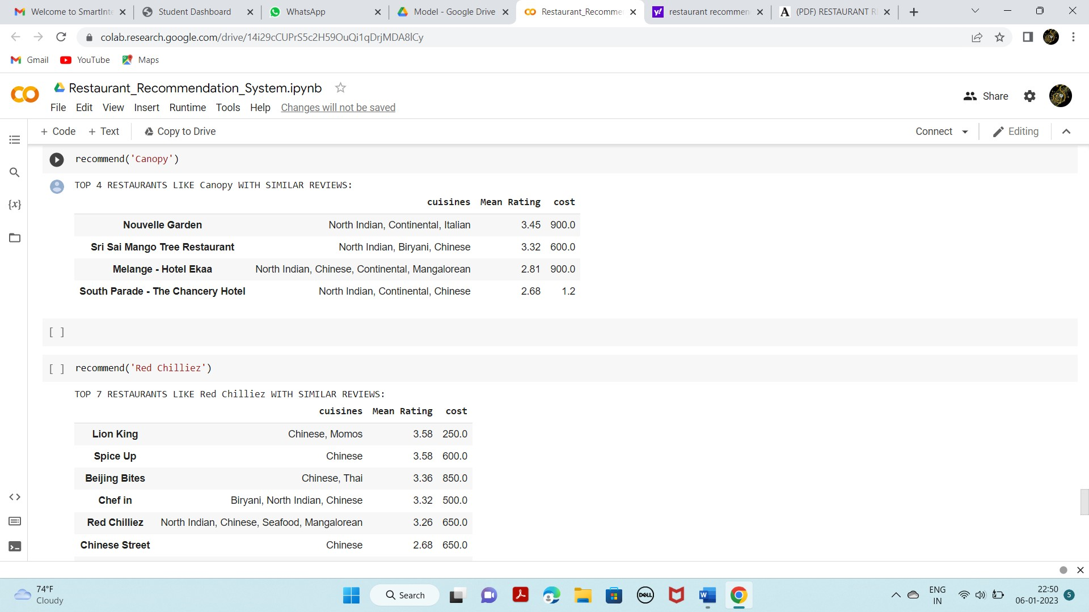

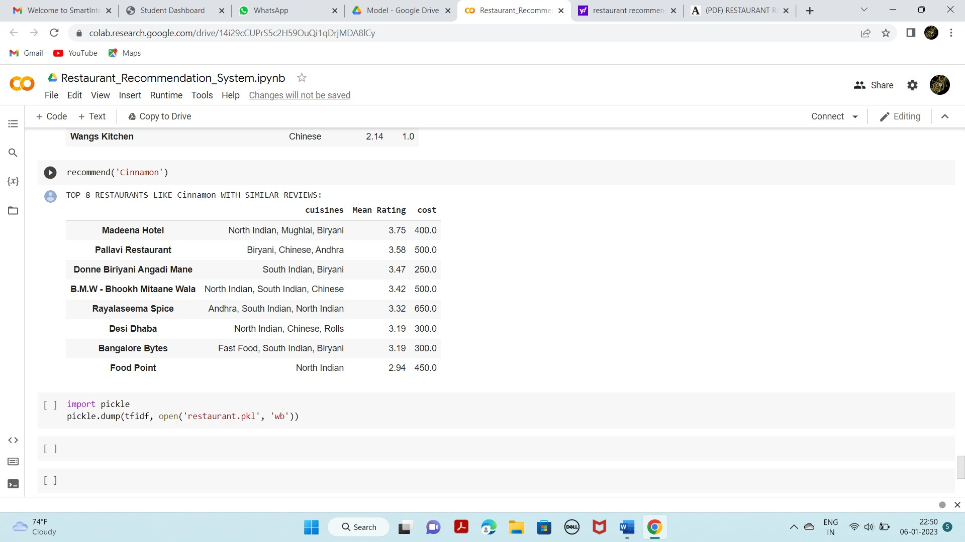

**2.2 .HTML CODE AND PYTHON CODE**

**app.py**

import numpy as np

import pandas as pd

import seaborn as sb

import matplotlib.pyplot as plt

import plotly.offline as py

import plotly.graph_objs as go

import seaborn as sns

import warnings

warnings.filterwarnings('always')

warnings.filterwarnings('ignore')

import nltk

from nltk.corpus import stopwords

from sklearn.metrics.pairwise import linear_kernel

from sklearn.feature_extraction.text import CountVectorizer

from sklearn.feature_extraction.text import TfidfVectorizer

import flask

from flask import Flask,render_template, request

import pickle

app = Flask(__name__) # initializing a flask app

model=pickle.load(open("restaurant.pkl",'rb')) #loading the model

#loading the updated dataset

zomato_df=pd.read_csv("restaurant1.csv")

@app.route('/')# route to display the home page

def home():

return render_template('home.html')#rendering the home page

@app.route('/extractor')

def extractor():

return render_template('extractor.html')

#extractor page

@app.route('/keywords', methods=['POST'])# route to show the predictions in a web UI

def keywords():

#typ=request.form['type']

output=request.form['output']

#if typ=="text":

#output=re.sub("[^a-zA-Z.,]"," ",output)

print(output)

print(type(output))

df_percent = zomato_df.sample(frac=0.5)

df_percent.set_index('name', inplace=True)

indices = pd.Series(df_percent.index)

# Creating tf-idf matrix

tfidf = TfidfVectorizer(analyzer='word', ngram_range=(1, 2), min_df=0, stop_words='english')

tfidf_matrix = tfidf.fit_transform(df_percent['reviews_list'].fillna(' '))

cosine_similarities = linear_kernel(tfidf_matrix, tfidf_matrix)

def recommend(name, cosine_similarities = cosine_similarities):

# Create a list to put top restaurants

recommend_restaurant = []

# Find the index of the hotel entered

idx = indices[indices == name].index[0]

# Find the restaurants with a similar cosine-sim value and order them from bigges number

score_series = pd.Series(cosine_similarities[idx]).sort_values(ascending=False)

# Extract top 30 restaurant indexes with a similar cosine-sim value

top30_indexes = list(score_series.iloc[0:31].index)

# Names of the top 30 restaurants

for each in top30_indexes:

recommend_restaurant.append(list(df_percent.index)[each])

# Creating the new data set to show similar restaurants

df_new = pd.DataFrame(columns=['cuisines', 'Mean Rating', 'cost'])

# Create the top 30 similar restaurants with some of their columns

for each in recommend_restaurant:

df_new = df_new.append(pd.DataFrame(df_percent[['cuisines','Mean Rating', 'cost']][df_percent.index == each].sample()))

# Drop the same named restaurants and sort only the top 10 by the highest rating

df_new = df_new.drop_duplicates(subset=['cuisines','Mean Rating', 'cost'], keep=False)

pd.set_option('display.max_columns', None)

df_new = df_new.sort_values(by='Mean Rating', ascending=False).head(10)

print('TOP %s RESTAURANTS LIKE %s WITH SIMILAR REVIEWS: ' % (str(len(df_new)), name))

return df_new

result = recommend(output)

print(result)

print(type(result))

#print(result[0])

#print(result[0])

# res = result.to_string(index=False)

#showing the prediction results in a UI

return render_template('keywords.html',keyword=result.to_html())

if __name__ == "__main__":

# running the app

app.run(debug=False)

**3.RESULTS**

This is the home main page that describes the project and summarizes it.

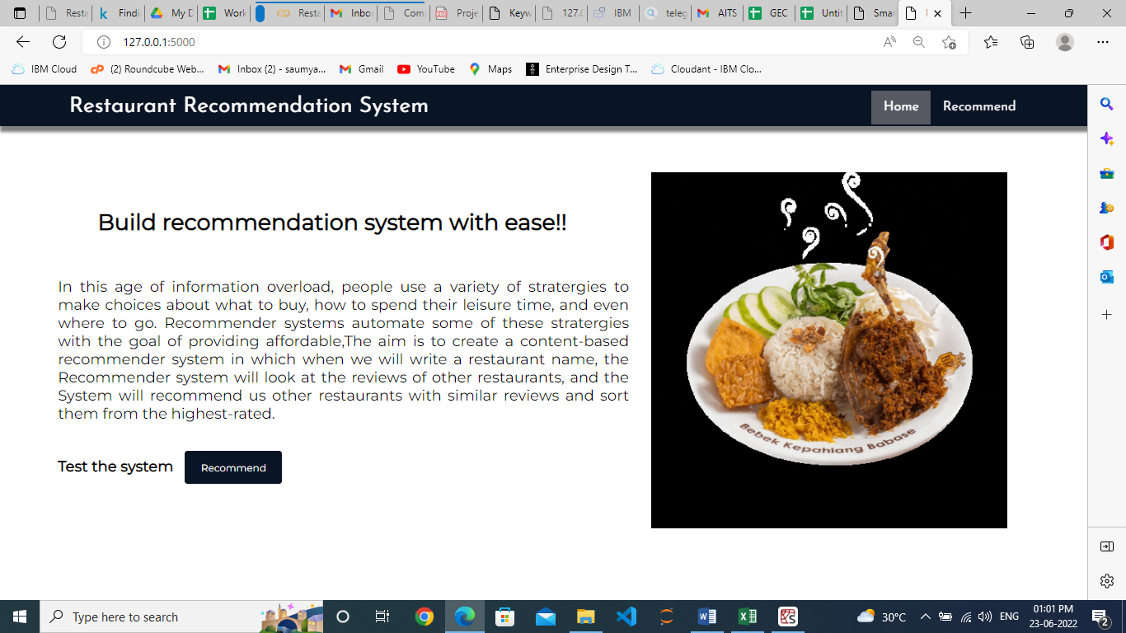

**Figure 1**: Home Page(Which gives introduction to Restaurant Recommendation system)

Checking recommendation for the restaurant: ‘Jalsa’

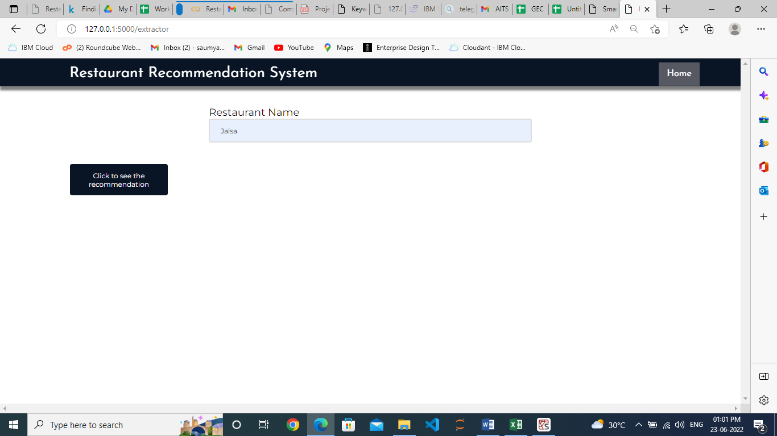

**Figure 2**:Input pages(Which takes inputs from User)

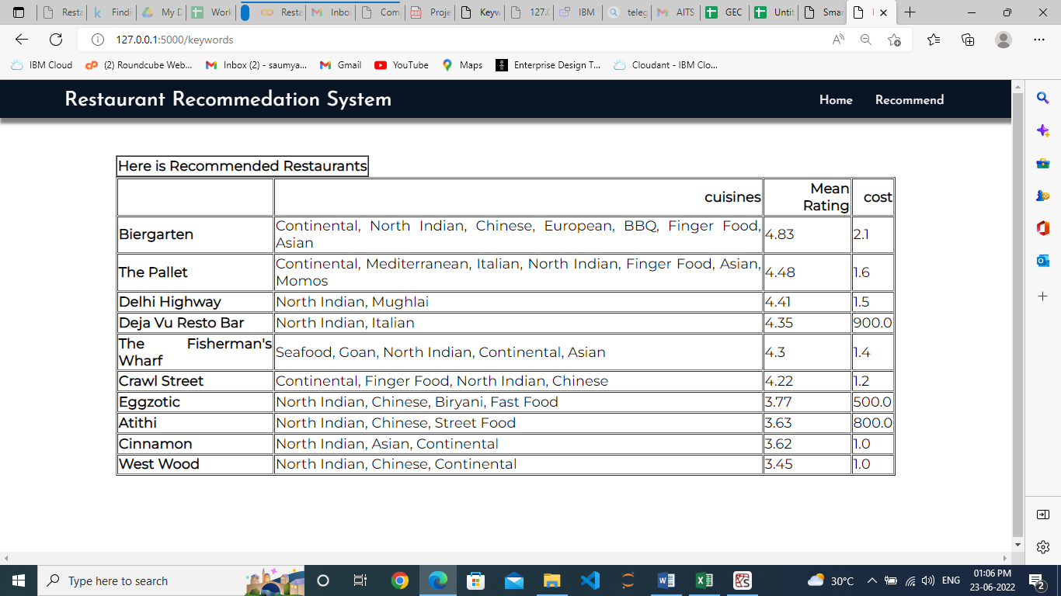

This is the prediction page where we will provide a restaurant name for which we will get the top recommended restaurants, which based on cuisines, mean rating (out of 5), cost in thousands.

**Figure 3**: Output Page (Display the Restaurant name and Details)

Checking recommendation for the restaurant ‘Cinnamon’

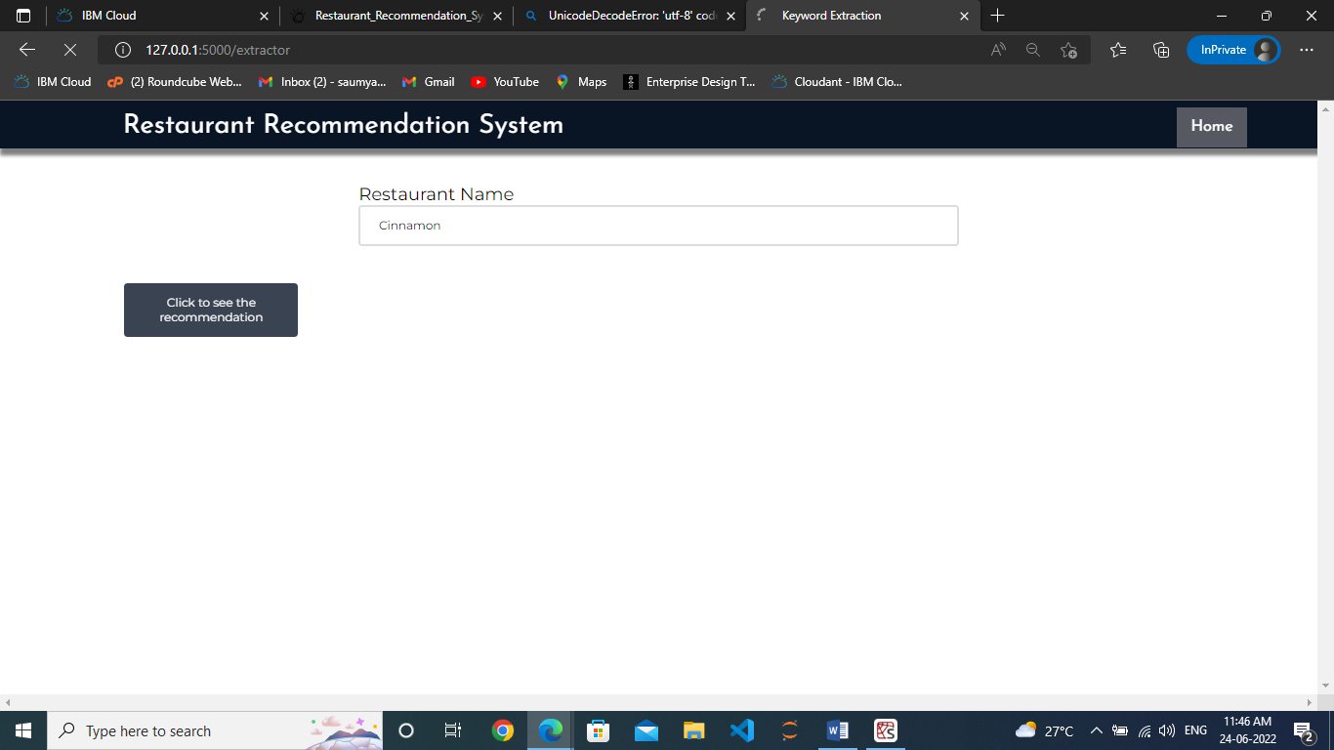

**Figure 4**: Home Page (Which gives introduction to Restaurant Recommendation system)

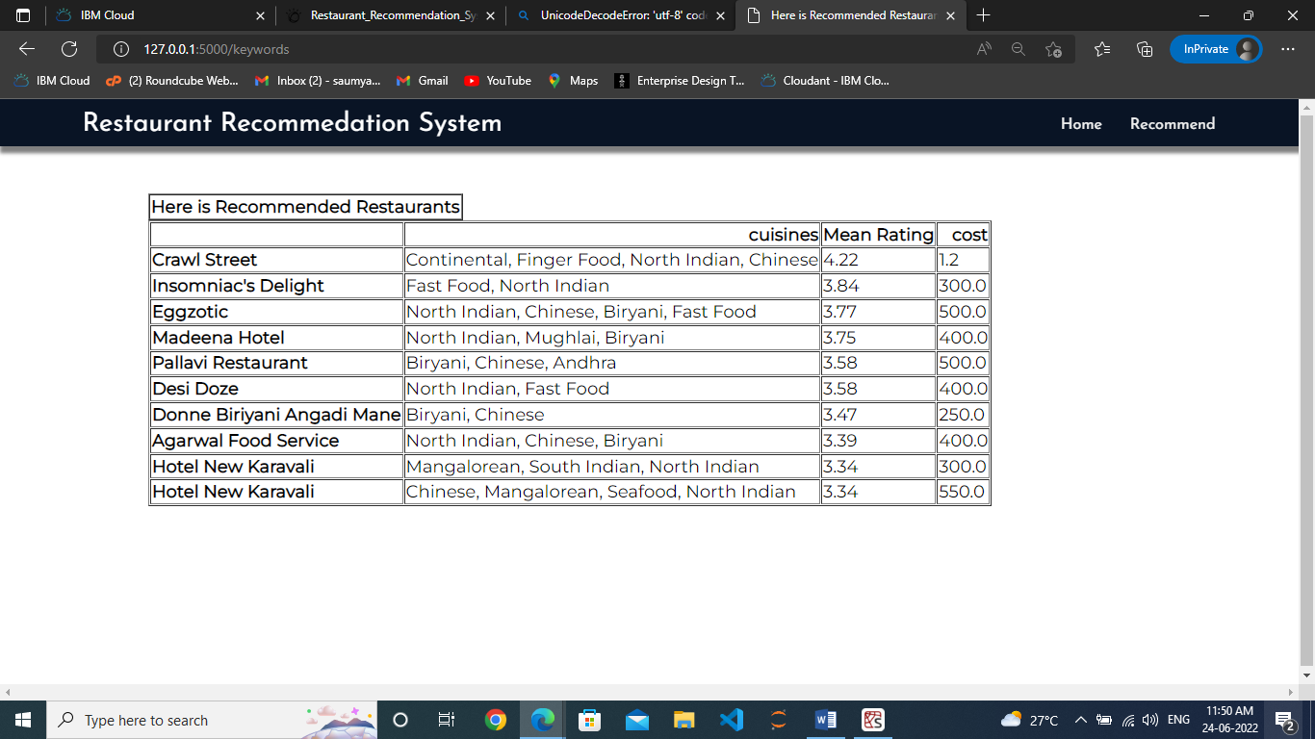

Finally, the prediction for the given restaurant inputs is shown.

**Figure 5**: Output Page (Display the Restaurant name and Details)

**4.APPLICATIONS**

* Can be used by tourists to find best reastaurant in new places.

**5.ADVANTAGES**

**Advantages:**

* You can try new foods.
* You do not have to cook.
* You get to spend time with family and friends.
* It's easier to feed large parties.
* Time is not wasted.

**6.DISADVANTAGES**

**Disadvantages:**

* Significant investments required.
* Too many choices.
* The complex onboarding process.
* Lack of data analytics capability.
* The 'cold start' problem.
* Inability to capture changes in user behavior.
* Privacy concerns.

**7.FUTURE SCOPE**

* To build more friendly graphical interfaces, the next goal for a further project is to improve the performance of system and improve the member's benefit such as providing more functions for member, like online reservation function, online order menu, and website, etc

**8. BIBILOGRAPHY**

<https://medium.com/mlearning-ai/restaurant-recommendation-system-based-on-the-content-in-reviews-dfc3351004db>

<https://www.kaggle.com/code/midouazerty/restaurant-recommendation-system-using-ml>

<https://towardsdatascience.com/yelp-restaurant-recommendation-system-capstone-project-264fe7a7dea1>

<https://www.academia.edu/85069823/RESTAURANT_RECOMMENDATION_SYSTEM>

**9.HELP FILE**

**PROJECT EXECUTION:**

STEP-1: Go to Start, search and launch ANACONDA NAVIGATOR.

STEP-2: After launching of ANACONDA NAVIGATOR, launch JUPYTER NOTEBOOK.

STEP-3: Open “Major project code” IPYNB file.

STEP-4: Then run all the cells.

STEP-5: All the data preprocessing, training and testing, model building, accuracy of the model can be showcased.

STEP-6: And a pickle file will be generated.

STEP-7: Create a Folder named FLASK on the DESKTOP. Extract the pickle file into this Flask Folder.

STEP-8: Extract all the html files (home.html, index.html, chance.html, nochance.html) and python file(app.py) into the FLASK Folder.

STEP-9: Then go back to ANACONDA NAVIGATOR and the launch the SPYDER.

STEP-10: After launching Spyder, give the path of FLASK FOLDER which you have

created on the DESKTOP.

STEP-11: Open all the app.py and html files present in the Flask Folder.

STEP-12: After running of the app.py, open ANACONDA PROMPT and follow the below steps: cd File Path→click enter

python app.py→click enter (We could see running of files).

STEP-13: Then open BROWSER, at the URL area type ―localhost:5000”.

STEP-14: Home page of the project will be displayed.

STEP-15: Click on ―Go to Predict”. Directly it will be navigated to index page.

STEP-16: A index page will be displayed where the user needs to give the inputs and then

click on ―” Predict”. Output will be famous restaurant in the particular area.